**ERROR TRACKING DASHBOARD**

**FILTERS:**

* **DATERANGE(Default Filter)**

**2.1 Total No of error**

SELECT COUNT(EVENT)

FROM FIVETRAN.FIVETRAN_LOG.LOG

WHERE EVENT='WARNING' OR EVENT='SEVERE' AND _fivetran_synced=:daterange;

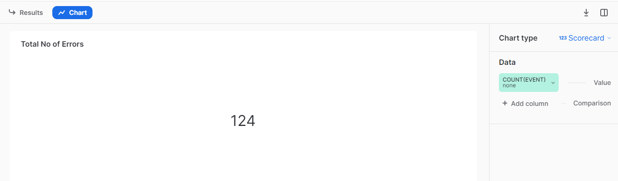

**2.2 Error Rate %**

SELECT

round( (SUM(CASE

WHEN event = 'SEVERE' Or event='WARNING'

THEN 1

ELSE 0

END)/

SUM(CASE

WHEN message_event = 'sync_end'

THEN 1

ELSE 0

END) )*100,2 )AS ERRORRATE

FROM

FIVETRAN.FIVETRAN_LOG.LOG

WHERE _fivetran_synced=:daterange;

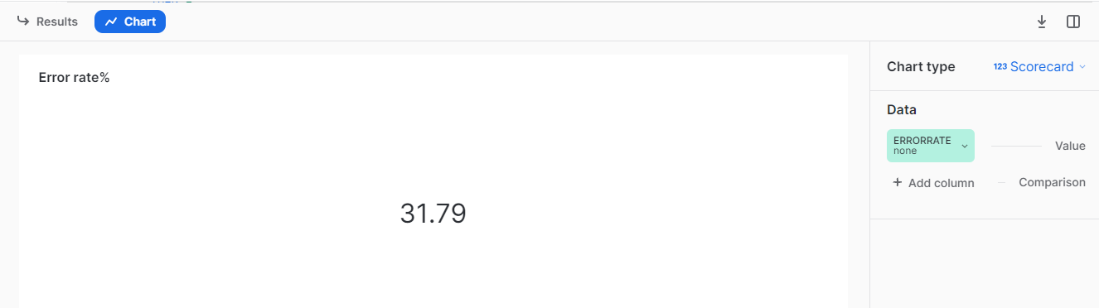

**2.3 Trend Of unsuccessful sync**

select date_trunc('day',time_stamp) as date,count(event) as sync_count,split_part(parse_json(message_data):status,':',1) as status

from FIVETRAN.FIVETRAN_LOG.LOG

where event='SEVERE' or event='WARNING' AND _fivetran_synced=:daterange

group by date_trunc('day',time_stamp),status;

select (SYNC_ID) as sync_count,parse_json(message_data):status as Status,_fivetran_synced

from fivetran.fivetran_log.log

where message_event='sync_end' AND EVENT = 'SEVERE' or event='WARNING' ;

group by sync_count,

group by Status,

group by_fivetran_synced;

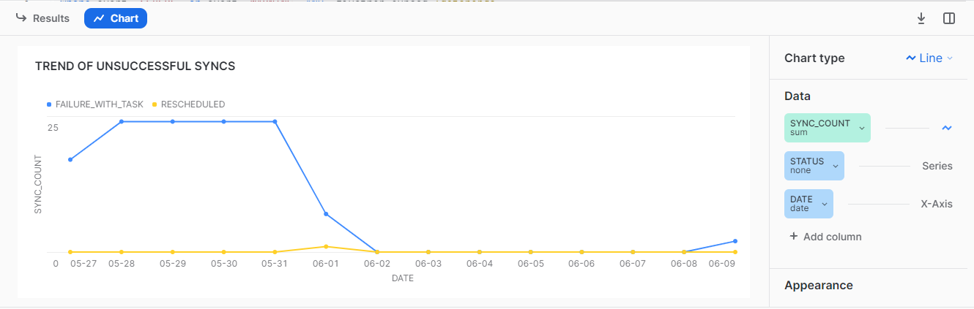

**2.4 Common error messages**

select distinct split_part(parse_json(message_data):reason,':',1) As Error_message, COUNT(parse_json(message_data):reason) as UNSUCCESSFUL_SYNC_COUNT,parse_json(message_data):status as Status,parse_json(message_data):reason as full_error_message

from "FIVETRAN"."FIVETRAN_LOG"."LOG"

where event = 'SEVERE'or event='WARNING' AND _fivetran_synced=:daterange

group by connector_id,parse_json(message_data):status,

parse_json(message_data):reason;

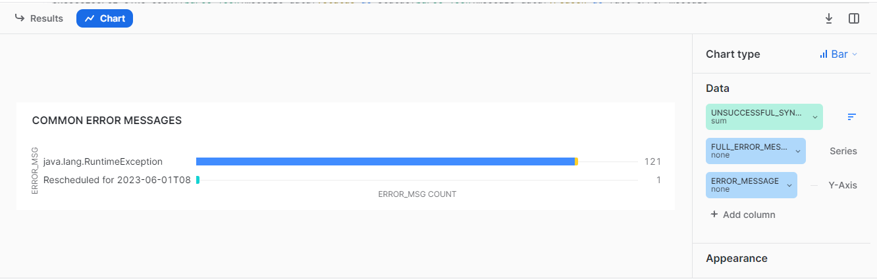

**2.5 Error rate per Connector**

SELECT

top 7 connector_id,

COUNT(CASE WHEN event IN ('SEVERE', 'WARNING') THEN 1 END) AS event_count,

COUNT(CASE WHEN message_event = 'sync_end' THEN 1 END) AS total_sync,

case when total_sync >0 then ROUND( (event_count/total_sync)*100,2) end as ERROR_RATE

FROM

FIVETRAN.FIVETRAN_LOG.LOG

where connector_id is not null AND _fivetran_synced=:daterange

GROUP BY

connector_id

order by ERROR_RATE desc;

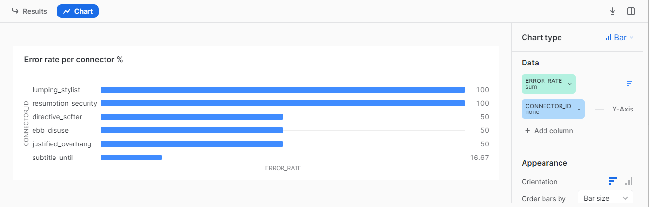

**2.6 Failed sync history**

select connector_id,event,time_stamp,parse_json(message_data):reason AS Error_message

from FIVETRAN.FIVETRAN_LOG.LOG

where (event='SEVERE' or event='WARNING') AND _fivetran_synced=:daterange and CONNECTOR_ID=:Connector_Id;

